NUAMES Robotics 2nd Annual Spaghetti Dinner and Silent Auction
When: October 22nd, 2014
Time: Doors open at 5:30 pm
Dinner’s at 6:00
Doors will close at 8:00
Where: Weber State Davis Campus Building D3 1st floor Ballroom
Events: Robotics Demonstrations, Presentations, and Silent Auction
Minimum Donation: Table of 6-$125
Single Seats-$25
How: Call or email NUAMES Robotics Mentors at
nuamesrobotics@gmail.com
801-395-3350
Menu: House Salad, Spaghetti and Meatballs with bread sticks, Dessert
We would love it if you were to buy a table, seat, or donate items for our silent auction.
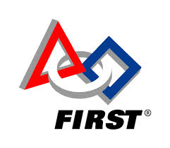
Thank you!

